 smart agriculture refers to the usage of technologies like Internet of Things, sensors, location systems, robots and artificial intelligence on your farm.

1. **HOW IT WORKS**

* Sensors (LoRa controllers) are installed in fields, greenhouses, orchards and other areas, the condition of which you want to control, and measure the parameters you are interested in: air temperature and humidity, soil moisture, etc.
* Sensors are connected to SQ CONTROLLER SIGNAL A and transmit data using the LoRaWAN® network.
* The information collected by the controller from the sensors is transmitted to the Hotspot point, from there - through storage on a cloud server - the data is sent to you or your employees.
* If necessary, in response to the indicators received, you can run certain actions according to pre-programmed algorithms - turn on watering, increase lighting, etc.

1. **SOLUTIONS INCLUDED**

* **Soil moisture and health** solutions that constantly optimize components for maximum growth.
* **Plant health monitoring** to make sure everything is growing big and strong.
* **Irrigation optimization** with sensor solutions that measure and monitor ideal irrigation parameters.
* **Remote valve control** solutions to keep irrigation and other systems working to peak performance.
* **Environmental monitoring,** including temperature, humidity, air quality, and light to provide constant feedback and optimization in every corner of grow facility.
* **Access monitoring** to provide or restrict access and to ensure maximum safety around the field or in the grow facility.
* **Asset tracking** to monitor the whereabouts of equipment and supplies.
* **Silo level monitoring** to measure and monitor storage.
* **Cattle/livestock health and tracking** solutions to measure and monitor the parameters you require for your heard.

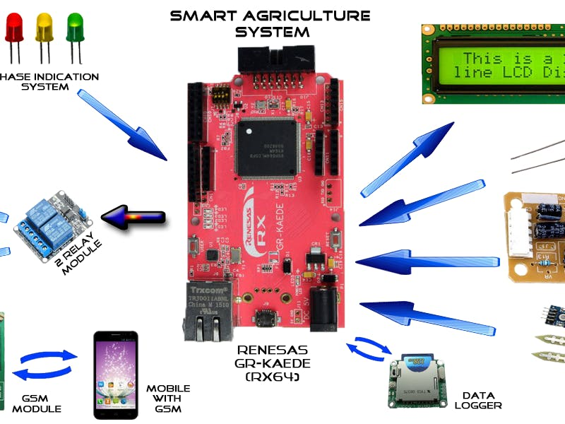v